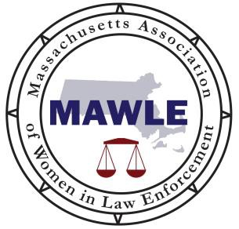

MASSACHUSETTS ASSOCIATION OF WOMEN IN LAW ENFORCEMENT
25 Dorchester St
PO Box #52031
Boston, MA 02205

www.mawle.org
Non-Profit §501(c) (3)

Lieutenant June T. Murphy Scholarship

Checklist

- ☐ Application On – line application process ONLY!

- ☐ Identity documentation
        - Are you a female? ☐ yes ☐ no
- Have you been a Massachusetts resident for at least 2 years? ☐ yes ☐ no
- Are you a US Citizen? ☐ yes ☐ no

- ☐ Supporting Documentation

Acceptable forms of identification are included, but not limited to birth certificate, passport, social security card, US certificate, government issued photo identifications, such as license, etc. MUST supply proof.

- ☐ Resume

- ☐ Essay

Describing applicant intention in pursuing a career in Law Enforcement, criminal justice, and what the scholarship means to her. Personal essay typed in 400 – 450 words.

- ☐ Transcript Must be official document from attending High School.
- Does the transcript reflect up to second semester of 12th grade? ☐ yes ☐ no
- Does the transcript have an “official stamp”? ☐ yes ☐ no

- ☐ Acceptance Official letter of acceptance from accredited college or university.
- Does the transcript have an “official stamp”? ☐ yes ☐ no
- Were you accepted into a fulltime program with a major in Law Enforcement/Criminal Justice ☐ yes ☐ no

- ☐ Recommendation Letters (2 count) From adult mentor, teacher, guidance counselor or other non-family member.

- ☐ FAFSA
- Do you qualify for Federal Assistance? ☐ yes ☐ no

- ☐ Deadline Did you submit your application packet by the deadline? ☐ yes ☐ no

On – line application process ONLY. Deadline – Friday, April 11, 2025 at 5:00 p.m.

